**DAY 3 – SESSION 1**

**Template Driven Form - Create a new component for editing employee details**

**Editemptemp.component.ts:**

import { Component, OnInit } from '@angular/core';

@Component({

selector: 'app-editemptemplate',

templateUrl: './editemptemplate.component.html',

styleUrls: ['./editemptemplate.component.css']

})

export class EditemptemplateComponent implements OnInit {

ngOnInit(): void {

}

public employees:string;

public myname:string;

constructor() {

this.employees = "";

this.myname="";

}

public emp:employee={Id:1,Name:"John",Salary:10000,Permanent:false, Dept:{Id:1,Name:"Payroll"},skills:[{id:1,Name:"html"},{id:2,Name:"Css"},{id:3,Name:"Javascript"}]};

public departmentslist:any[]=[{Id:1,Name:"Payroll"},{Id:2,Name:"Internal"},{Id:3,Name:"Hr"}];

public OnSubmit():void{

console.log(this.emp);

}

}

class employee{

public Id:number=0;

public Name:string="";

public Salary:number=0;

public Permanent:boolean=true;

public Dept:Department={Id:1,Name:"Payroll"};

public skills:any[]=[{}];

}

class Department{

public Id:number=1;

public Name:string="";

}

**Editemptemp.component.html:**

<strong>Edit Employees</strong>

<br>

<br>

<form><label><strong>Name:</strong><input type="text" name="name1" #name1></label>

{{name1.value}}

<br>

<br></form>

<hr>

<label>

<strong>Lname:</strong>

<input type="text" name="name" [(ngModel)]="employees" #name=ngModel PlaceHolder="Lname" pattern="[a-z]+" minlength="3" maxlength="10">

{{employees}}

<div>name.invalid - {{name.invalid}}</div>

<div>name.touched - {{name.touched}}</div>

<div>name.dirty - {{name.dirty}}</div>

<div>name.errors.minlength or maxlength - {{name.errors?.minlength | json}}</div>

</label>

<hr>

<br><br>

<label>

<strong>Name:</strong>

<input type="text" name="t1" [(ngModel)]="myname" minlength="2" maxlength="10" #t1=ngModel required="true"><br>

</label>

<span class="c1" *ngIf="t1.invalid && t1.dirty">Name must be 2 characters long</span>

<br>

<br>

<hr>

<form #empForm="ngForm" (submit)="OnSubmit()">

<div class="block">

<label>

<strong>Name:</strong>

<input type="text" [(ngModel)]="emp.Name" [ngModelOptions]="{standalone: true}">

</label>

<br>

<br>

<label>

<strong>Salary:</strong>

<input type="number" [(ngModel)]="emp.Salary" Pattern="\d+" [ngModelOptions]="{standalone: true}">

</label>

<br><br>

<label>

<strong>Is Permanent or Not?</strong>

<input type="radio" name="permanent" [(ngModel)]="emp.Permanent" [value]="true">Yes

<input type="radio" name="permanent" [(ngModel)]="emp.Permanent" [value]="false">No

</label>

<label>

</label>

<button type="submit" [disabled]="!empForm.valid">Save</button>

</div>

</form>

<div class="block">

<strong>Employee Model</strong><br>

<pre>{{emp | json }}</pre>

</div>

**App.component.html:**

<style>

body { font-family: Segoe UI, Arial

} a { text-decoration: none }

</style>

<h3>Angular Learning <br><a [routerLink]="['/view']">View Employees</a> ||<a [routerLink]="['/edit']">Edit Employees</a>||<a [routerLink]="['/edittemp']">Edit Employees Template driven</a>||

<a [routerLink]="['quantity']">Quantity Increment</a></h3>

<div>

<router-outlet></router-outlet>

**Output**

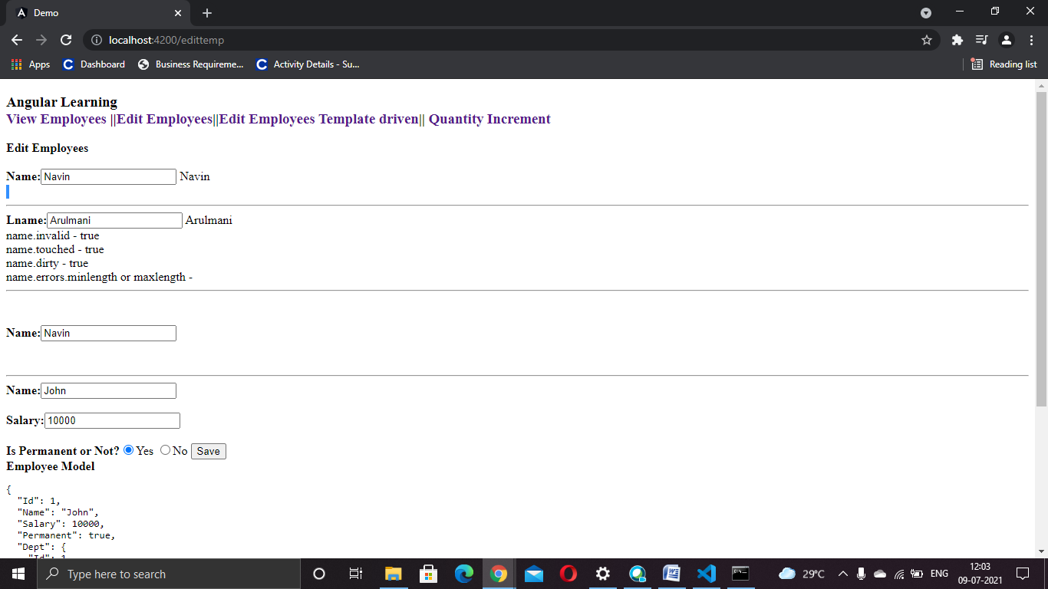

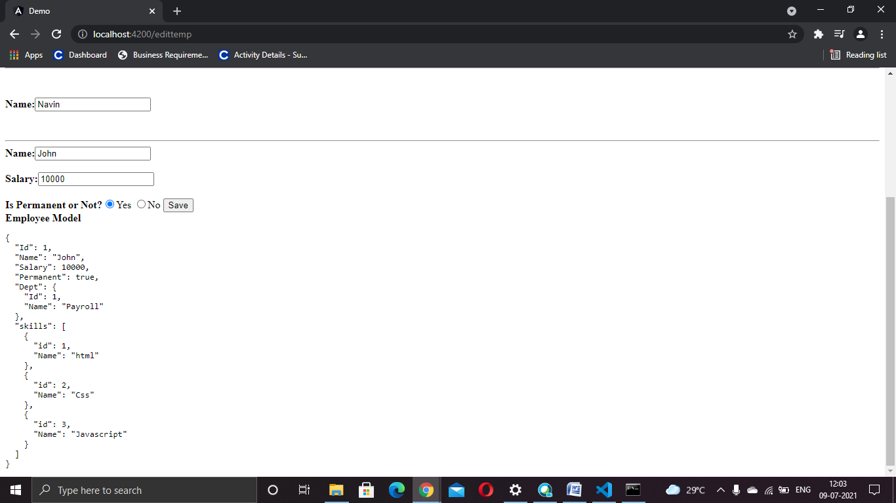

**Session 2**

**Reactive Form - New Component and Name field inclusion**

**Editempreactive.component.html:**

<h2>Edit Employee</h2>

<label>

Name: <input type="text" [formControl]="Name">

</label>

<br>

<br>

<div>

<form [formGroup]="deptF">

<h3>Department</h3>

<select formControlName="department">

<option *ngFor="let department of departmentslist"

[ngValue]="department"

[selected]="department.Id == emp.Dept.Id">

{{department.Name}}

</option>

</select>

</form>

</div>

**Editempreactive.component.ts**

import { Component, OnInit } from '@angular/core';

import {FormGroup,FormControl,Validators} from '@angular/forms';

@Component({

selector: 'app-editempreactive',

templateUrl: './editempreactive.component.html',

styleUrls: ['./editempreactive.component.css']

})

export class EditempreactiveComponent implements OnInit {

constructor() { }

ngOnInit(): void {

}

public emp:employee={Id:1,Name:"John",Salary:10000,Permanent:false, Dept:{Id:1,Name:"Payroll"},skills:[{id:1,Name:"html"},{id:2,Name:"Css"},{id:3,Name:"Javascript"}]};

public departmentslist:any[]=[{Id:1,Name:"Payroll"},{Id:2,Name:"Internal"},{Id:3,Name:"Hr"}];

Name=new FormControl('John');

public empForm:FormGroup = new FormGroup({

'name': new FormControl(this.emp.Name, [

Validators.required,

Validators.minLength(4),

Validators.maxLength(20)

])

});

public deptF:FormGroup = new FormGroup({

'department': new FormControl("")

});

}

class employee{

public Id:number=0;

public Name:string="";

public Salary:number=0;

public Permanent:boolean=true;

public Dept:Department={Id:1,Name:"Payroll"};

public skills:any[]=[{}];

}

class Department{

public Id:number=1;

public Name:string="";

}

**App.component.html**

<style>

body { font-family: Segoe UI, Arial\

} a { text-decoration: none }

</style>

<h3>Angular Learning <br><a [routerLink]="['/view']">View Employees</a> ||<a [routerLink]="['/edit']">Edit Employees</a>||<a [routerLink]="['/edittemp']">Edit Employees Template driven</a>||<a [routerLink]="['/editreactive']">Edit Employee reactive</a>||

<a [routerLink]="['quantity']">Quantity Increment</a></h3>

<div>

<router-outlet></router-outlet>

**Ouput**

